Assignment #1

Task #1 #2 #3 #4 #5 #6

|  |  |
| --- | --- |
| **PREPARED FOR**Robo-Tech Team | **PREPARED DATE**Aug 13, 2018 |

Task #1

|  |  |  |
| --- | --- | --- |
| **ITEM** | **Specifications** | **PRICE** |
| [T200 Thruster](https://www.bluerobotics.com/store/thrusters/t200-thruster/) |  | $169 |
| [ESC](https://www.bluerobotics.com/store/electronics/besc30-r3/) |  | $25 |
| [Analog Camera](https://www.bluerobotics.com/store/electronics/low-light-ntsc-camera/) | * 2.1mm lens. * wide-angle field of view of 128 degrees horizontally and 96 degrees vertically. * The camera consists of the 1/3″ Sony Super HAD 810 CCD sensor and the Sony Effio-A 4151 System IC, with 700TVL resolution and digital noise reduction. * The camera outputs a standard NTSC or PAL signal compatible with many displays and capture cards. | $32 |
| [Pressure Sensor](https://www.bluerobotics.com/store/electronics/bar30-sensor-pcb-r1/) | * 0.2 bar resolution. * Depth measurement resolution of 2mm * Can also be use in air to measure altitude. * Measures up to 30 bar (300m depth) and communicates over I2C. * It operates on 3.3V I2C voltage but can accept power input up to 5.5V. * It includes four solder pads for ground, 3.3V-5.5V power, and 3.3V I2C lines. * includes a temperature sensor accurate to ±1°C, with data also accessible through I2C. * [Datasheet](http://www.te.com/commerce/DocumentDelivery/DDEController?Action=showdoc&DocId=Data+Sheet%7FMS5837-30BA%7FB1%7Fpdf%7FEnglish%7FENG_DS_MS5837-30BA_B1.pdf%7FCAT-BLPS0017). | $54 |
| [Power cables](https://www.bluerobotics.com/store/cables/cab-nbpuf-4utp-26awg/) |  | $4.50 / m |

# 

Task #2

* Accelerometer :- Accelerometers are available that can measure acceleration in one, two, or three orthogonal axes. They are typically used in one of three modes:

1. As an inertial measurement of velocity and position.
2. As a sensor of inclination, tilt, or orientation in 2 or 3 dimensions, as referenced from the acceleration of gravity (1 g = 9.8m/s2).
3. As a vibration or impact (shock) sensor.
4. More details (<http://www.sensorwiki.org/doku.php/sensors/accelerometer>).

* Gyroscope :- A gyroscope is a device used primarily for navigation and measurement of angular velocity. Gyroscopes are available that can measure rotational velocity in 1, 2, or 3 directions. 3-axis gyroscopes are often implemented with a 3-axis accelerometer to provide a full 6 degree-of-freedom (DoF) motion tracking system.
  + For more details (<http://www.sensorwiki.org/doku.php/sensors/gyroscope>).
* Compass :- A Compass Sensor is a digital compass that measures the earth's magnetic field and outputs a value representing the current heading. The magnetic heading is calculated to the nearest 1° and returned as a number from 0 to 359.
* Water sensor :- A water sensor is a device used in the detection of the water level for various applications. Water sensors are of several types that include ultrasonic sensors, pressure transducers, bubblers, and float sensors. (More details: <https://www.azosensors.com/article.aspx?ArticleID=225>).
* Pressure sensor :- A pressure sensor is a device for pressure measurement of gases or liquids. Pressure is an expression of the force required to stop a fluid from expanding, and is usually stated in terms of force per unit area. (More details: <https://en.wikipedia.org/wiki/Pressure_sensor>).
* Temperature sensor :- A tempreature sensor is a device for temperature measurement. and is usually stated in terms of force per unit area. (More details: [http://www.sensorwiki.org/doku.php/sensors/temperature?s[]=temperature&s[]=sensor](http://www.sensorwiki.org/doku.php/sensors/temperature?s%5B%5D=temperature&s%5B%5D=sensor)).

Task #3

* Top (5) cameras with offers
  + [{1}](https://goo.gl/MRoqqm)
  + [{2}](https://goo.gl/8VsN7G)
  + [{3}](https://goo.gl/dNSKeC)
  + [{4}](https://goo.gl/zsMZzn)
  + [{5}](https://goo.gl/Rk1hNE)

Task #5

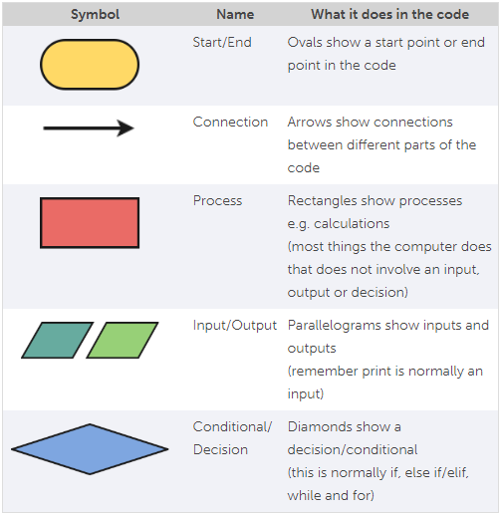

Task #6

